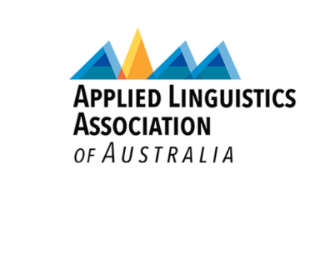**Applied Linguistics Association of Australia 2025 Conference**

**Garramilla/Darwin, 17-19 November 2025**

**Conference Travel and Attendance Scholarship Application**

This competitive scholarship covers Early Bird Conference Registration and a travel reimbursement of up to AU$1000 ALAA members from Southeast Asia, Pacific and developing countries who have an accepted proposal for the ALAA 2025 Conference. Priority will be given to postgraduate students and early career researchers.

There are a maximum of three scholarships available, and applications will be evaluated against the eligibility criteria on a first come, first served basis. Successful applicants will be notified in due course.

**Eligibility criteria:**

* Hold current ALAA membership since at least June 30 of the current year
* Have a presentation accepted for the ALAA 2025 Conference
* Be affiliated with a university located in Southeast Asia, Pacific, or a developing country
* Not be in receipt of other conference support

**Application procedure:**

To be considered, applicants must include:

* A completed application form
* A copy of your abstract submitted for presentation at the ALAA 2025 Conference
* A letter of support from your supervisor or employer

Please email the completed application form and supporting documentation to [alaaconference2025@cdu.edu.au](mailto:alaaconference2025@cdu.edu.au) by the application deadline.

**Applications close 20 June 2025.**

**Applied Linguistics Association of Australia 2025 Conference**

**Garramilla/Darwin, 17-19 November 2025**

**Conference Travel and Attendance Scholarship Application**

|  |  |
| --- | --- |
| **Applicant Details** | Name:  Email:  Phone: |
| **University Name** |  |
| **Current Position** |  |
| **Country of Residence** |  |
| **Conference Attendance** | Whole Conference (3 days)  Day Pass (1 day) |
| **Abstract Submitted** | Yes  No |
| **Scholarship Support Parameters** | Postgraduate Student  Early Career Researcher  **Other conference support currently received?**  Yes  No  **Proposed presentation sub-theme**  Real-world challenges and innovations  Power dynamics in languaging  Transformative pedagogy  AI and disruptive technology in applied linguistics |
| **How will attending this conference benefit you?**  **(max. 200 words)** |  |
| Letter of support from supervisor/employer |
| **Abstract Title** |  |
| **Abstract** |  |
| **Supporting Documents (if required)** |  |